Name: Archana Deshpande, Assistant Professor, Deogiri Institute of Engineering & Management Studies, Aurangabad.

Foundation Program in ICT for Education (FDP 101x)
Course Journal
Week-1
Module 1: Moving from physical classroom to on-line classroom
Different interactions in learning using physical/online classroom
Learner
3

2

1

Teacher /Facilitator

Content

- Physical Classroom:
- This is the interaction between Teacher and Learner. Teacher explains the concept through lecture and asks the questions. The learner gives answer
- This is the interaction between Learner and Content. Learner solves the problem by doing.
- Teacher prepares the lecture by using books/ wiki books/ppt s etc.which implies Teacher – Content interaction.
- On-line Classroom: In on-line classroom role of teacher is replaced by facilitator and content is in the form of resources’ like videos, web links, research papers etc.In discussion forum Learner-Learner interaction takes place.

DATE:28-09-2018 TIME: 6.00P.M.
LeD 1.1 : From Physical classroom to online class room
Q1) Can you list the various interactions between these three components Learner, Content
and Teacher in a physical class room?

- Teacher delivers lecture by writing key points on the black board and providing material to the students. Learner read the notes and able to write the examinations.

LeD 1.2 : Learning Dialogues.

Q2) What is the equivalent of instructor videos in a physical class room?

- The teacher should prepare a lesson plan and give lecture to the students and ask questions while giving lecture.

Q3) What additional features does the video provide in an online setting ?
- We can watch online videos at any time and anywhere. We can listen videos any number of times. We can pause the video at any point. We can adjust volume. We can answer practice questions and can assess ourselves.

LeD 1.3 : Learning by Doing Activities.

Q4). What advantage do you see in answering practice questions immediately after LeD videos?
- We can recollect the information which we have listen and can assess ourselves.

DATE: 29-09-2018 TIME: 2.00P.M.
LeD 1.4 : Learning extension Resources.

Q5). What is the function of Assimilation quiz?
- We can get more knowledge about the topic by viewing related website links.

LeD 1.5 : Learning experience Interactions.

Q6). What are the advantages of having a structured group discussion with a focus question and specific instructions?
- This type of discussion provides in-depth information on the topic and opinions of selected participants. We can collect a large number of qualitative information in a short span.

LeD 1.6 : Maintaining the Course journal.

Q7). Write one advantage of maintaining a course journal?
- We can maintain important points of the content and we can share our views to others.

Module 2:
2.1 Learning Dialogue Video or LeDs
Reflection spot:
What is Internet ? How does it work?
Ans. Internet is a complex network capable of providing a variety of information and communication means. It uses protocol to connect to various devices.
In the Internet, each computer connected to the Internet should have a unique address. Internet addresses are in the form nnn.nnn.nnn.nnn where nnn must be a number from 0 - 255. This address is known as an IP address. (IP stands for Internet Protocol)
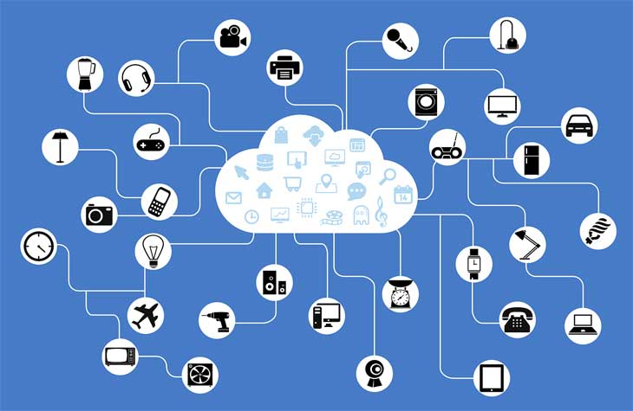

Reflection spot:
How does information travel from your computer to other networks?
Ans. Data travels across the internet in the form of small packets. Each packet carry a maximum of 1,500 bytes. Around these packets is a wrapper with a header and a footer. The information contained in the wrapper tells computers what kind of data is in the packet, how it fits together with other data, where the data came from and the data's final destination.
Reflection spot:
What happens when you send e mails?
Ans: Simple Mail Transfer Protocol (SMTP) is an Internet standard for electronic mail (email) transmission. The recipient of the mail also has an Internet Service Provider and a mail server. When the SMTP server decides that it's time to send email, it connects to the destination mail server and transmits the message to it. It uses SMTP to speak to each other.

Q 1) Reflection spot : What is the equivalent of such a video in a regular teaching-learning interaction within your classroom?
A) Teacher delivers the concept and content to the students .
Q 2) Reflection spot :What additional features does the video provide you apart from the regular information transmission of the content?
A) Medium features like video player.volume,speed etc.
- 2.2 Learning-by-Doing Activities or LbDs.
Q 3) Reflection spot :What advantage do you see in answering these questions immediately after watching LeDs?
- To make learner attentative.

Module : 3 Basics of ICT

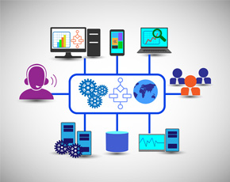

Week-2 (Web Presence for Teachers)
Module -1 : The Internet

Reflection spot:
What is Internet ? How does it work?
Ans. Internet is a complex network capable of providing a variety of information and communication means. It uses protocol to connect to various devices.
In the Internet, each computer connected to the Internet should have a unique address. Internet addresses are in the form nnn.nnn.nnn.nnn where nnn must be a number from 0 - 255. This address is known as an IP address. (IP stands for Internet Protocol)

Reflection spot:
How does information travel from your computer to other networks?
Ans. Data travels across the internet in the form of small packets. Each packet carry a maximum of 1,500 bytes. Around these packets is a wrapper with a header and a footer. The information contained in the wrapper tells computers what kind of data is in the packet, how it fits together with other data, where the data came from and the data's final destination.
Reflection spot:
What happens when you send e mails?
Ans: Simple Mail Transfer Protocol (SMTP) is an Internet standard for electronic mail (email) transmission. The recipient of the mail also has an Internet Service Provider and a mail server. When the SMTP server decides that it's time to send email, it connects to the destination mail server and transmits the message to it. It uses SMTP to speak to each other.

Module 2: Word Press for Website Creation
WordPress is a free and open-source content management system based on PHP and MySQL. The main features of wordpress include a plugin architecture and a template system. It is associated with blogging, but supports other types of web content including more traditional mailing lists and forums, media galleries. This is digital platform to teach the students and communicate the content through internet.

Week 3 Creating your own video resources:-
There are two main sections and ten sub-sections in Week 3. Here ideas about how to create your own video resources is explained. Starting with learning dialogues on visual presentations, we come to create our own video resources using selected screen casting software. An interesting LxI activity is to interact with peers in the Discussion Forum.

Visual Presentation Skills 1

LBD 1:--
Title – Creating Your Own Video Resource
- Visual Presentation Skill >>
Preparing visual presentations involves three processes as follows:

LbD 2 :--
Different graphics are used to represent different types of contents.

Visual Presentation Skills
You have to think consider two more factors: colour and typography and how to use them effectively. The use of different colours and fonts while making visual presentations is an important aspect.

- Color Schemes

Colour: - Mood, Expressions, Convention, Meaning
- Colour guidelines:-
- More Contrast:- More Readability
- Dim lit room:- White text an black
- Bright room :- Black text on White
- Vivid / pale colors :- less readability
- color Scheme to suit your topic

- Avoid colours :- Pink , red, magenta

- Typography:-
Activity: - Bold ,italics, underline, color, all together

Typography Guidelines:-

1. Use minimum font: 2 more advisable more than that is chaotic
2. Use font option to emphasize one is advisable 1, 2 can be Used rarely
3. Use alignment feature; left is preferred, but depends as on template at times use grid

General Guidelines
1. Use 6*6 rule
1. Not more than 6 Pt. /on a Slide
2. Not more than 6 words in each
- Choose a template which pt. promotes readability
- Use phrases or abbreviated sentence rather than full sentences
- Select a sans serif font & use them 24pt.or larger.
- Incorporate high quality graphics that reinforce your messages
- provide references to ANY artifact that you use form someone else presentation website ,paper, lectures etc.
- Use animation slide transition,audio,and video sparingly
- Light the most imp. information
- Create a handout to accompany your presentation.
Other Software:
- A screencast is a digital recording of computer screen output, also known as a video screen capture, often containing audio narration. The term screencast compares with the related term screenshot; whereas screenshot generates a single picture of a computer screen, a screencast is essentially a movie of the changes over time that a user sees on a computer screen, enhanced with audio narration.
The softwares marked with GPL (GNU General Public License) in this list come under the Copyleft, allowing users to freely distribute and modify the original program.
The following non-GPL softwares are also popularly used.
1. Screencast-O-Matic
2. Techsmith Jing (for Windows and OSX)
3. Techsmith Camtasia (for Windows)
4. Quicktime (for OSX

Comparison of screencasting software

GNU General Public License
The GNU General Public License (GNU GPL or GPL) is a widely used free software license, which guarantees end users the freedom to run, study, share and modify the software.[

Multimedia Principles
Whenever you want to develop any teaching-learning content such as a PowerPoint presentation, a video resource, an animation, a learning site such as the one you have created with wordpress or you are developing an online course, you will need to consider how you will get your students engaged while using the materials without distracting them. Multimedia principles help learners to learn better when they are using different learning materials of your course. Watch the videos below by Prof. Richard E. Mayer to give you important considerations you can consider when developing your teaching-learning resources such as the screencasting activity.
- Multimedia principles:-

Week 3 gives the overall introduction with practical demos of how to create and use the tools in ICT to improve the teaching with blended effect.

WEEK 4 : Learning Management Systems
FDP101x

Foundation Program in ICT for Education

MOODLE: An Open Source Learning Management System

An LMS is a software tool that helps you deliver and manage online courses and training to your intended audience (e.g. students). It helps to organize and manage courses, activities, results and provide feedback to your audience. One of the most commonly used LMS is called Modular Object-Oriented Dynamic Learning Environment (MOODLE).
- It has many features that help in the effective delivery of courses, including: forums, quizzes, chats, glossary, peer assessment assignments and many other.

Discussion Forum netiquette: In this animated video it discusses about the rules of Forum netiquettes. Some of Key points are as follows:
- Rule 1: Don’t Shout Online.

- Rule 2: Be discerning with emojis and emoticons

- Rule 3: Use meaningful subject titles.

- Rule 4: Do not say or do anything online that ours elders don’t like it, Mind your language and Watch our pictures
- Rule 5: Don’t Argue, respect the decision of moderators at all times.

- Rule 6: Thou shalt not steal i.e. Before using text or image we should take permission.

Activity to be posted:

Q1: Can you identify the pedagogic feature that has been used in the animation video on Forum Etiquette?

A1: The pedagogic features used in the animation video are LbD i.e Learning By doing and LxI i.e Learning experience Interaction as well as Learning Dialogues (LeD) too. However the Reflective Spot is definetly missing.

Q2: What is one new thing that you learnt about discussion forum etiquette?

A2: One new thing that I learnt about the discussion form etiquette is that we should use meaning subject titles while interacting as well as we must keep our language soft and polite, avoid use of rash language.
LeD 4.1: MOODLE in IIT Bombay

Prof. Upendra Bhandarkar from Mechanical Engineering Department, IIT Bombay; explain how best we can use Moodle to give a new learning experience to our students. In 6 different videos he explain:

1. Course Setup 2. Editing Sections 3. Adding Resources

4. Creating Assignment 5. Creating Discussion Forum 6. Creating Quizzes.
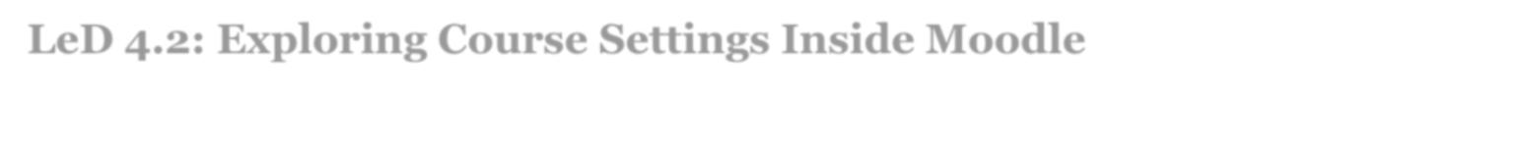

LeD 4.2: Exploring Course Settings Inside Moodle

In this video Prof. Upendra Bhandarkar, show us how his various courses are offered through moodle. Also what he can do or as a teacher within the Moodle.

The most important button in the administration section which is this editing option.
  - Administrative Section -> Editing option

  - We have Button add some activity or resources.

  - Hide Button

  - We can change/Edit following information about the course o The course title

o Course Category

o Summary : add files using drag and drop it

o Course Format: Weekly / topic o No. of Sections:

o Course Layout:
- Guest Access

- Role Renaming
LeD 4.3: Video: Editing Sections in a Course

In this video, Prof. Bhandarkar talks about the various features available in side a Moodle for a teacher & familiarize us with through a course in moodle.
- setting up assignments especially in numerical method.

- add tables

Led 4.4: Video: Creating Assignments in Moodle

- In this video, Prof. Bhandarkar shows us the process of creating assignments in our own course using moodle.

Foundation Program in ICT for Education September 25, 2018 24 | P a g e

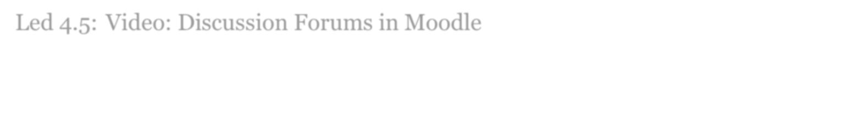
Led 4.5: Video: Discussion Forums in Moodle

In Prof. Bhandarkar, explain, how he sets up discussion forum in his moodle course. He also discusses about the various blocks that are on the right side including a search forum, a latest news forum, upcoming events and recent activity.
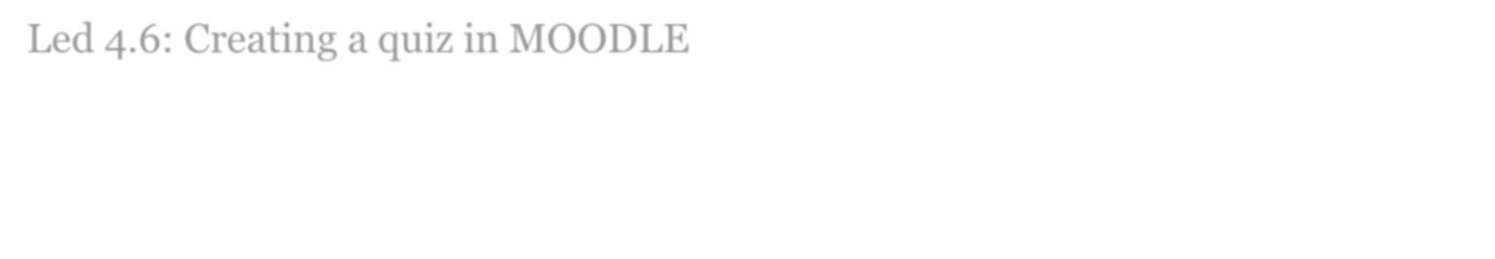

Led 4.6: Creating a quiz in MOODLE

In this video Prof. Bhandarkar explains how quizzes can be setup in MOODLE. What all different options are available? How to setup timing, schedule and different types of questions that can be put in quiz. Also Evaluating techniques and other too are discussed.

WEEK 4, also included a FACE – TO- FACE INTERACTION SESSION on 6th and 7th Oct-2018 through A-View

Week 5 : Putting it all Together

Week contains:-

- Learning Extension Resources - Creative Commons Licenses and Open Source Tools for Smart Classrooms

- Learning Dialogue - Summarizing what you have learnt in this FDP till now

- Learning Experience Interaction - Discussion on technology that you can integrate in the classroom and its challenges

Learning Extension Resources: Open Source Tools for Smart

Classrooms: Tools for Smart Classrooms

The tools which are free and open source discussed includes:

- Open Board for Interactive Whiteboards:

  - OpenBoard is an open source cross-platform teaching software for interactive whiteboard designed primarily for use in schools and universities.

  - It can be used both with interactive whiteboards or in a dual-screen setup with a pen-tablet display and a beamer.

  - OpenBoard is released under the GPLv3 License and maintained by the community on GitHub.
- Mediawiki for asynchronous collaborations:

  - MediaWiki is a free server-based software, licensed under the GNU General Public License (GPL). It's designed to run on a large server farm for a website that gets millions of hits per day.

  - MediaWiki is an extremely powerful, scalable software and a feature-rich wiki implementation that uses PHP to process and display data stored in a database, such as MySQL.

  - Pages use MediaWiki's wikitext format, so that users without knowledge of HTML or CSS can edit them easily.

- Github for collaborations particularly useful for Computer Science Teachers

We are also informed about the proprietory applications such as:

- ConceptBoard or Realtimeboard for real time collaborations

- Confluence by Atlassian as a team collaboration software

Learning Dialogue: Understanding the Learning Purpose of Activities.

In this learning dialogue, Dr. Jayakrishnan M summaries the various technologies and activities that we have done till now.

Week 1

- It was an introductory week where they familiarized us with the format of the course, and the basic pedagogy and how various features of IITBombayX is used for achieving this.

- In terms of learning goals, they had also introduced us to the idea of keeping a course journal.
- There were three different technologies that were exposed to us,

  - IITBombayX,

  - Document Editors,

  - File Sharing services,

through meaningful and aligned activities.

Week 2
- It was focused on web presence of the faculty.

- The larger goal was to familiarize us with the content management systems that are available online and the technology of WordPress was discussed in detail.

- They also provided learning extension resources for another technology - Drupal, that is increasingly becoming a popular choice for creation of multifunctional websites.

Week 3
- Focused on learning mgmt. which goes beyond mere content management.

- Introduced us to MOODLE, an open source Learning Management Systems.

- It provided us with videos of MOODLE that are used in IIT Bombay and additionally provided links to a Demo MOODLE site that we can use for practice.

Week 4

- Week 4 focused on a tool for audio-video content creation- Camstudio for screen casting.

- As self-exploration we were provided links to other popular tools that can be used for the same purpose

- The practice activity in Week 4 focused on creating a screencast in your own vernacular language.
- Week 4 also had an interactions through A-VIEW.

Learning Experience Interaction:

FOCUS QUESTION

- Among the various technologies that you have been exposed to, which will be an easier technology to integrate into your classroom immediately (current academic semester/next academic semester).

Answer: The Numbers of technologies that we are exposed, of them the first that I would like to implement is presence of faculty on web. I would be preparing the video using screen-

o-metric software and sharing it on the website to the students, which will be more interesting & easy for students to understand the lessons.

Also, I would also like to use the Moodle for content management, Preparing Assignments for students, Adding Quizzes, and initiating a discussion on a topic in DISCUSSION FORUM.

- What challenges do you expect while integrating this technology into your classroom? Answer: As the first task is quite simple and its implementation won’t have much problem to me, however for the second task, I will definitely have to train our students about the Moodle and its features.

